MOBILE COMPUTING

BelFure ( Tempat Belanja Furniture)


Oleh
Ahmad Yori Januari | 1715061021
Nadya Merdeka Wati | 1715061010

PROGRAM STUDI TEKNIK INFORMATIKA

JURUSAN TEKNIK ELEKTRO

FAKULTAS TEKNIK

UNIVERSITAS LAMPUNG

2020
MOCKUP APLIKASI JUAL BELI FURNITURE

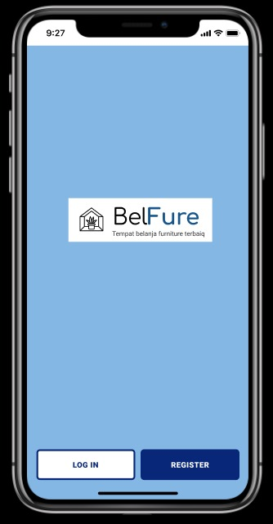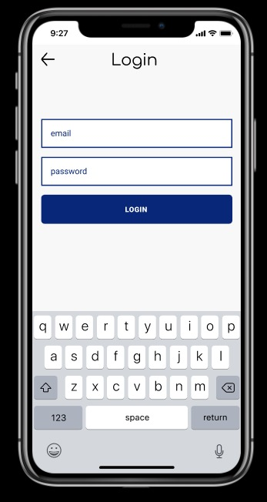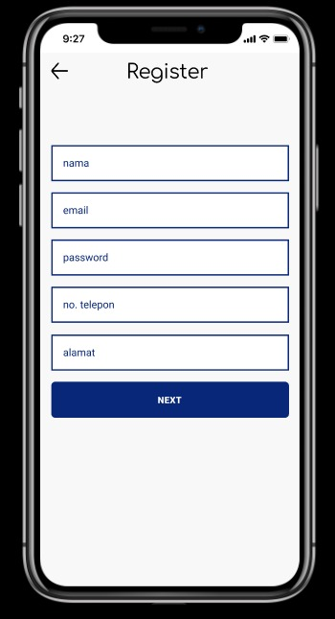
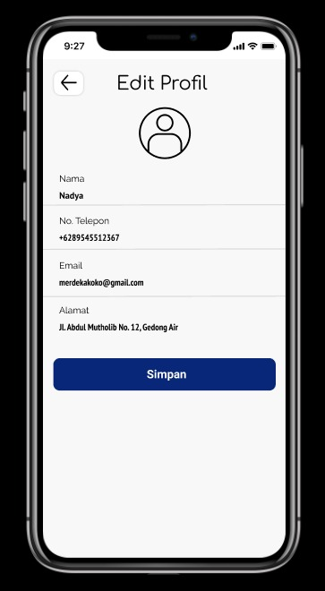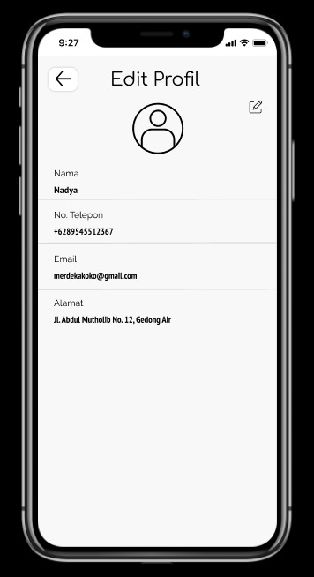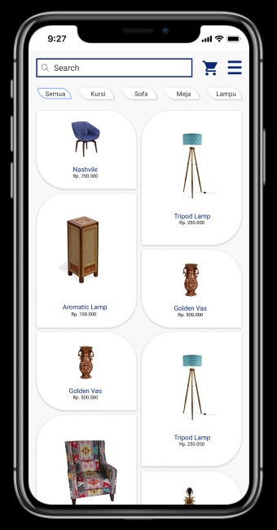

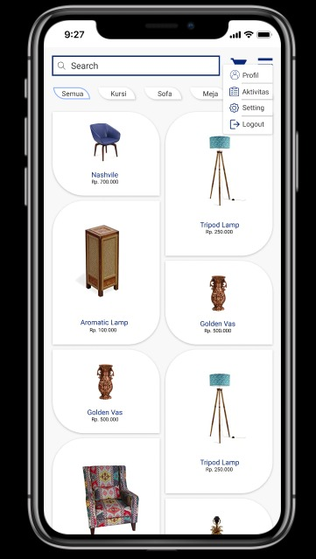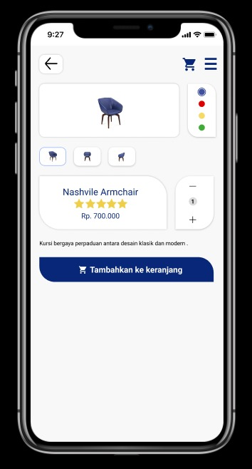

BelFure could be solution for everyone who want to buy furniture easily and trusted.
who contribute on this project is : Ahmad Yori Januari (1715061021) and Nadya Merdeka Wati (1715061010)

Github link:
https://github.com/ahmadyori1021/mocomTB

Mock-up link:
https://www.figma.com/proto/OcXovAyKpbo8BxfDvGQ831/Prototyping-in-Figma-Copy?node-id=60%3A512&viewport=-2695%2C-2206%2C0.942570686340332&scaling=scale-down

